**GreenBox**

User Guide

Congratulations on owning your very own GreenBox! You are a few steps away from easily caring for any and every kind of plant you can imagine! Simply set up, choose your settings, and sit back as your GreenBox simply and precisely monitors the internal environment.

**Getting to know your GreenBox**

1

2

5

6

4

3

10

11

7

8

9

14

12

13

1. Power Switch
2. Temperature and Humidity display
3. Light knob (0 - 24hrs)
4. Air circulation knob (0 - 24hrs)
5. Humidity knob (40 - 90%)
6. Temperature knob (10 – 40 °C)
7. 110 Volt Power cord
8. Water tank
9. Water filters
10. Temperature & humidity sensor
11. Lights
12. Heater
13. Cooler
14. Fan

## **Setting up your GreenBox**

This guide will walk you through the initial setup of the GreenBox. Once setup is finished the GreenBox will continue working on its own with regular maintenance described below.

1. Make sure that wicking filter is in place.

2) Fill water reservoir

3) Plug power cord into standard 110 V outlet.

WARNING: POWER CORDS THAT ARE DAMAGED, BROKEN, MODIFIED, TRAPPED UNDER HEAVY OBJECTS, PULLERD HARD, OR BENT SEVERELY ARE ELECTRIC SHOCK AND FIRE HAZARDS

**Operating your GreenBox**

Once setup is completed, place your plant into the main chamber of the GreenBox.

BEFORE powering on your GreenBox, use the 4 knobs to select your desired conditions.

* The first knob selects the amount in hours of light that you want per day (from 0 to 24).
* The second knob selects the amount of time in hours that you want the ventilation fan to run per day (from 0 to 24).
* The third knob selects your desired humidity levels in percent (from 40 to 90).
* The fourth knob selects your desired temperature in degrees Celsius (from 10 to 40).

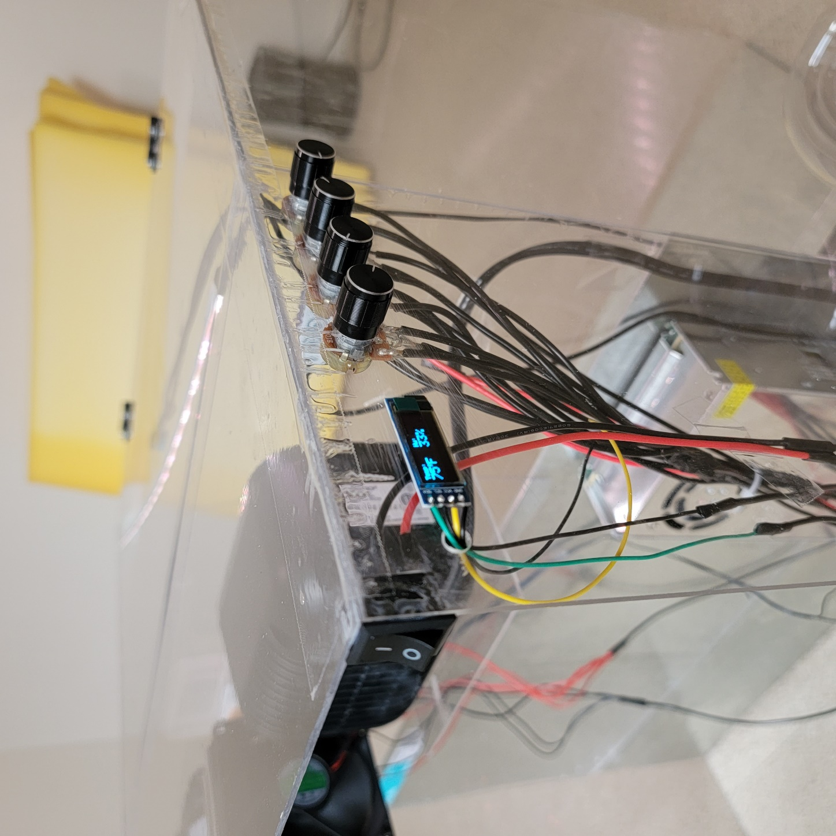

Once you have input your conditions, use the power switch to turn the device on.

The GreenBox will show each of the input conditions momentarily on the display while it is starting up.

The GreenBox will then continuously display and correct the humidity and temperature inside the chamber on the display.

WARNING: Keep hands clear of fans to avoid minor injury.

**Troubleshooting**

Q: What if the display stops working?

A: Turn off the GreenBox using the power switch, wait 10 seconds, and turn it back on. The GreenBox resets every time it is powered off.

Q: What if the chamber isn’t getting as humid as the input says it should?

A: Check that the water tank is full, and the filters are not excessively dirty. Also check to see if the fan is properly spinning. If the fan is not spinning, try restarting the device.

Q: What if the display doesn’t show the same level as the knobs?

A: Pull the knob straight out to remove the plastic cap. Twist the metal portion of the knob as far down toward 0 as possible, then replace the cap with the indicator pointed toward 0.

## **Conclusion**

The GreenBox provides an extremely simple way to create and maintain the ideal environment for plants. The setup is a quick, simple process that will have you growing plants in minutes.

If you have questions or concerns, send an email to [zacdwil@hotmail.com](mailto:zacdwil@hotmail.com)

**GreenBox**